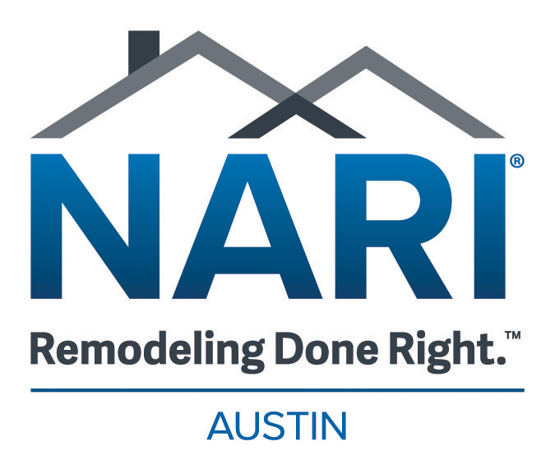

Young Professional Award Nomination Form

The Young Professional Award is designed to recognize NARI’s young remodeling professionals for their efforts and achievements in the remodeling industry. .
Entrants must be a member in good standing for at least 2 or more years and be under the age of 40 at the time of application. He/she must have demonstrated their commitment to NARI by serving on a committee, and/or served as a board member, and have demonstrated a strong commitment to NARI by developing themselves professionally as a leader in their industry.
Eligible Nominees: Austin NARI Individual
Person to be Nominated:

Person/Company making Nomination:

Your Contact Information

Why do you feel this person deserves to be recognized for the Young Professional Award? _________________________________________
____________________________________________________________
____________________________________________________________
____________________________________________________________
___________________________________________________________

The deadline to receive nominations is October 25th, 2024

Send nominations via email to kayvon@austinnari.org with

Young Professional in the subject line.

