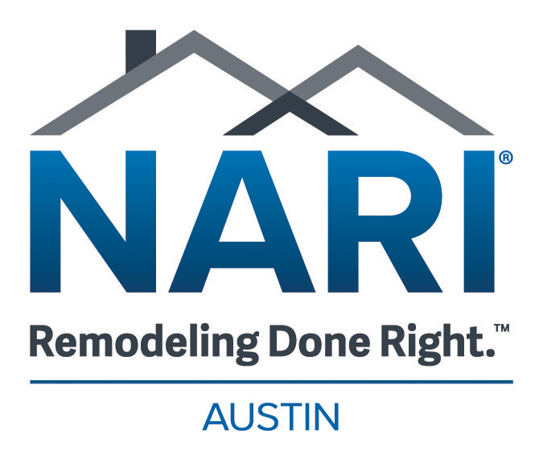

Vendor Support Member of the Year Nomination Form

The Austin NARI Vendor Support (i.e. bank, magazine, insurance, etc.) Member of the Year Award recognizes any Austin NARI vendor supporting member who has demonstrated a strong commitment to NARI, the professional remodeling industry and the communities in which they do business.

Nominees must have demonstrated their involvement in any or all of the following activities:

- The support and promotion of NARI and Austin NARI
- Participation in Austin NARI activities
- Recruitment of new Austin NARI members
- Participation in community service projects
- Maintaining good community relations

Any entry whose use of the NARI logo, certification designation, CotY or any other NARI logo that does not comply with usage rules and criteria as set forth by NARI Headquarters will not be eligible.

Eligible Nominees: Austin NARI Vendor Support Member in Good Standing

Eligible to Nominate: Austin NARI Member Company, Austin NARI Member Company Individual

Person to be Nominated: _______________________________________________

Person/Company making Nomination: ____________________________________

Your Contact Information: ______________________________________________

Why do you feel this person deserves to be recognized for the Vendor Support Member of the Year Award? _____________________________________________
______________________________________________________________________
______________________________________________________________________
______________________________________________________________________
______________________________________________________________________

The deadline to receive nominations is October 25th, 2024
Send nominations via email to kayvon@austinnari.org with

Vendor Support Member of the Year in the subject line.

