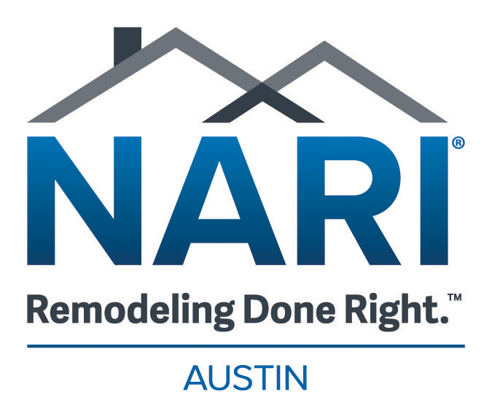

Community Service Award Nomination Form

The Community Service Award is designed to recognize NARI’s remodeling professionals for their efforts and achievements in the remodeling industry.
The Community Service Award may be presented to NARI Members that donates time, energy, and materials to help area individuals or groups in need. The aid could be related to construction services rendered for free or simply time and material help in conjunction with another organization’s effort. This award is judged on value of contribution to community over time and potential future benefits.
Eligible Nominees: Austin NARI Member/Company
Person/Company to be Nominated:

Person/Company making Nomination:

Your Contact Information

Why do you feel this person deserves to be recognized for the Community Service Award? _________________________________________
____________________________________________________________
____________________________________________________________
____________________________________________________________
___________________________________________________________

The deadline to receive nominations is October 25th, 2024

Send nominations via email to kayvon@austinnari.org with

Community Service in the subject line.

